Streaming Clustering Algorithms: Empirical Evaluation and Trade-off Analysis

1. Introduction
Clustering is one of the most fundamental problems in unsupervised learning. The goal of clustering is to partition a dataset into groups of similar points while separating dissimilar ones.
Among clustering algorithms, k-means is one of the most widely used methods due to its simplicity and strong empirical performance. However, classical k-means assumes that the entire dataset can be stored in memory and processed multiple times.
Modern data processing environments often violate this assumption. Many real-world applications produce data continuously in the form of streams, where the volume of data can be extremely large and the entire dataset cannot be stored or repeatedly scanned.
Streaming algorithms address this challenge by processing data incrementally while maintaining only a compact summary of the data observed so far.
In this project we study several algorithms for streaming k-means clustering and compare their empirical performance.
The main objectives of this work are:
- to implement several streaming clustering algorithms from the literature
- to compare their runtime, memory usage, and clustering quality
- to evaluate the trade-offs between these metrics
- to examine whether empirical behavior matches theoretical predictions
The algorithms evaluated in this work include:
- Guha et al. (STREAM clustering)
- Ailon et al. (Streaming k-means#)
- Boutsidis et al. (Random projection for k-means)
- Charikar et al. (Facility-location based clustering)
- Offline k-means (baseline)

2. Background and Related Work

2.1 Clustering and the k-means objective
Given a dataset of points in ℝ^d, the k-means clustering problem aims to find (k) centers that minimize the sum of squared distances between points and their nearest center.
The objective function is: $SSE = \sum_{\{i=1\}}^{\{n\}}{min_\{j=1..k\} ||x_{i}- c_{j}||²}$
where
- $x_{i}$ are data points
- ($c_{j}$) are cluster centers
Although k-means is simple and widely used, computing the optimal solution is NP-hard in general.
Many approximation algorithms have therefore been proposed.

2.2 Streaming clustering
In the streaming setting data arrives sequentially and algorithms must process points as they arrive.
The main constraints in streaming algorithms are:
- limited memory
- single-pass processing
- incremental updates
Streaming clustering algorithms typically maintain summaries of the data such as:
- coresets
- sketches
- compressed cluster summaries
These summaries approximate the clustering structure of the stream.

2.3 STREAM algorithm (Guha et al.)
Guha et al. proposed the STREAM framework, one of the earliest algorithms for clustering data streams.
The algorithm processes the stream in chunks. Each chunk is clustered to produce a small set of representative centers.
These summaries are combined using a merge-and-reduce hierarchy. Whenever two summaries appear at the same level they are merged and compressed again.
This approach ensures bounded memory usage while maintaining good approximation quality.

2.4 Streaming k-means# (Ailon et al.)
Ailon et al. proposed a streaming algorithm based on a randomized clustering procedure called k-means#.
The algorithm constructs a weighted summary of the data using repeated randomized sampling.
The final clustering solution is selected from several candidate solutions.
The algorithm introduces parameters controlling:
- coreset size
- number of repetitions
These parameters affect the balance between runtime and clustering accuracy.

2.5 Random projection for k-means (Boutsidis et al.)
Boutsidis et al. proposed an approach that accelerates clustering using randomized dimensionality reduction.
The algorithm projects the data into a lower dimensional space using a random projection matrix.
According to the Johnson–Lindenstrauss lemma, distances between points are approximately preserved with high probability.
Clustering is then performed in the reduced space, significantly lowering computational cost.

2.6 Facility location approach (Charikar)
Charikar and collaborators proposed a clustering algorithm inspired by the facility location problem.
Cluster centers are opened probabilistically based on the distance of new points from existing centers and a facility cost parameter.
This approach allows dynamically adjusting cluster centers as new points arrive.

3. Streaming Model and Problem Definition
In this project we study the k-means clustering problem in a streaming setting.
A stream of points: [x_1, x_2, ..., x_n] arrives sequentially.
The algorithm must maintain (k) cluster centers that approximately minimize the k-means objective while using limited memory.
We adopt the insertion-only streaming model.
In this model:
- new data points arrive sequentially
- previously seen points cannot be removed or modified
- the algorithm processes each point only once
To simulate the stream in experiments we process datasets in chunks. Each chunk represents a portion of the stream and algorithms update their summaries incrementally.
Although data is processed in batches for efficiency, the summaries maintained by the algorithms never remove previously processed data.

4. Algorithms
The following algorithms were implemented in the experimental framework.
Offline K-Means: The classical k-means algorithm is used as a baseline.
This algorithm has access to the full dataset and iteratively updates cluster centers until convergence.

MiniBatch K-Means: MiniBatch k-means is an approximate version of k-means that processes small random batches of data at a time.
It significantly reduces runtime while maintaining competitive clustering quality.

Guha STREAM: The STREAM algorithm processes data in chunks.
For each chunk:
- run k-means to produce summary centers
- assign weights to the centers
- insert the summary into a hierarchical merge-and-reduce structure
If two summaries appear at the same level they are merged and compressed again.

Ailon Streaming k-means#: The Ailon algorithm constructs a weighted summary using randomized sampling.
For each block of data the algorithm runs the k-means# procedure several times and keeps the best candidate clustering.
Parameters controlling this algorithm include:
- coreset size
- number of repetitions

Boutsidis Random Projection: The Boutsidis algorithm reduces the dimensionality of the data before clustering.
The projection dimension depends on the approximation parameter.
After projection, clustering is performed using MiniBatch k-means.

Charikar Streaming Clustering: The Charikar algorithm uses a facility-location inspired strategy.
When a new point arrives, a new cluster center may be opened with probability proportional to its distance from existing centers.
This approach dynamically adapts the clustering structure during the stream.

5. Experimental Setup

5.1 Datasets
Experiments were conducted on both synthetic and real datasets in order to evaluate the behavior of streaming clustering algorithms under controlled conditions as well as on real-world data.
Synthetic datasets were generated using scikit-learn data generators. These datasets simulate different clustering structures and allow systematic control over dataset size, dimensionality, and number of clusters.
The synthetic datasets include:
- Gaussian blob clusters (blobs)
- Anisotropic clusters created by applying linear transformations
- High-dimensional clusters with additional noise dimensions
- Imbalanced cluster distributions

For synthetic datasets we varied the following parameters:
Dataset sizes:
- n = 10,000
- n = 30,000
Dimensionalities:
- d = 10
- d = 25
Number of clusters:
- k = 8
- k = 16

These variations allow analyzing algorithm performance across datasets with different sizes and dimensional characteristics.
In addition to synthetic datasets, experiments were conducted on several real-world datasets:
  - Iris dataset
  - Forest CoverType dataset
  - MNIST handwritten digit dataset, where dimensionality was reduced using PCA to 50 dimensions.
For real datasets, the values of n, d, and k were derived directly from the dataset itself. Specifically:
  - n corresponds to the number of samples
  - d corresponds to the number of features
  - k corresponds to the number of unique labels in the dataset

Unlike synthetic datasets, real datasets were evaluated once per dataset using their inherent dimensionality and cluster structure.
Synthetic datasets were processed under multiple configurations of (n, d, k) to simulate different data stream environments. Real datasets were evaluated separately using their natural dimensionality and number of clusters. This avoids repeatedly loading large real datasets for artificial parameter configurations that do not reflect their true structure.

5.2 Evaluation metrics
The algorithms were evaluated using the following metrics.
Clustering quality
- SSE (sum of squared errors)
- ARI (Adjusted Rand Index)
- NMI (Normalized Mutual Information)
Streaming performance
- runtime
- throughput
- update time
- memory usage
Memory was measured in two ways:
- internal memory used by algorithm summaries
- peak memory consumption measured during execution
Dataset | Type | n | d | k
blobs | synthetic | 10k–30k | 10–25 | 8–16
anisotropic | synthetic | 10k–30k | 10–25 | 8–16
high_dim_sparseish | synthetic | 10k–30k | 10–25 | 8–16
imbalanced | synthetic | 10k–30k | 10–25 | 8–16
iris | real | 150 | 4 | 3
covertype | real | 50k | 54 | 7
mnist_pca50 | real | 20k | 50 | 10

5.3 Parameter tuning
Before running the main experiments, a parameter tuning phase was performed for each streaming algorithm.
For each algorithm, several parameter configurations were evaluated on a synthetic dataset using multiple random seeds. Performance was measured in terms of runtime, memory usage, and clustering quality.
The configuration achieving the best trade-off between these metrics was selected. The selected parameters were then fixed and used for all subsequent experiments on both synthetic and real datasets.

5.3.1 STREAM (Guha et al.)
The STREAM algorithm summarizes chunks of the stream into a fixed number of representative centers.
The main parameter controlling the algorithm is the summary size, determined by the parameter:
m_factor
which determines the number of centers stored in each summary level.
The summary size is approximately proportional to:
m ≈ m_factor × k
Increasing this parameter increases the number of stored summary centers.
Expected theoretical effects:
- larger summaries improve clustering accuracy
- larger summaries increase memory usage
- runtime may increase due to more expensive merge operations
In our experiments we evaluated several values of this parameter in order to analyze the trade-off between summary size and clustering performance.

5.3.2 Ailon Streaming k-means#
The Ailon algorithm maintains a coreset representation of the stream using a randomized clustering procedure.
Two parameters play an important role: coreset_factor, repeat_factor
The coreset factor determines the number of representative points sampled from each chunk, while the repetition factor determines how many times the randomized clustering procedure is executed.
Increasing these parameters typically improves clustering stability and accuracy but increases computational cost.
Parameter sweeps were performed to identify configurations that achieve a good balance between accuracy and runtime.

5.3.3 Boutsidis Random Projection
The Boutsidis algorithm reduces the dimensionality of the data using random projections before performing clustering.
The projection dimension is determined by the parameters:
ε (approximation parameter)
c₂ (constant factor)
The theoretical projection dimension is approximately: r = O(k / ε² log k)
Smaller values of ε produce larger projection dimensions and therefore more accurate approximations of the original data.
However, increasing the projection dimension also increases memory consumption and computational cost.
In our experiments the datasets had dimensionalities of:
d = 10 and d = 25.
The Boutsidis algorithm typically demonstrates its advantages in much higher dimensional settings (often 100+ dimensions). However, running experiments in such high dimensions significantly increases runtime.
Therefore, for practical experimental purposes we restricted the dimensionality to moderate values while still analyzing the algorithm’s behavior.

5.3.4 Charikar Facility Location Algorithm
The Charikar algorithm opens cluster centers dynamically based on the distance between incoming points and existing centers.
Two parameters influence the algorithm: Β, γ
These parameters affect the probability of opening new cluster centers and the thresholds used during the algorithm’s phases.
Higher values typically allow the algorithm to open more centers, which may improve clustering accuracy but increase memory usage.
Parameter sweeps were conducted to study how these parameters influence clustering behavior.

5.4. Overall experimental pipeline:
The overall experimental procedure consisted of the following stages:
- Perform parameter tuning for each streaming algorithm.
- Select the best parameter configuration based on quality, runtime, and memory usage.
- Run experiments on synthetic datasets while varying (n, d, k).
- Run experiments on real datasets using their inherent dataset properties.
- Record performance metrics including runtime, memory usage, and clustering quality.
- Analyze trade-offs between algorithms.

6. Results
The experimental results are divided into two parts.
First, we present the results of the parameter tuning phase for each algorithm.
Second, we present the overall comparison of the algorithms on the full set of datasets.

6.1 Parameter Tuning Results
In the parameter tuning phase, multiple parameter configurations were evaluated for each streaming algorithm.
For each algorithm, we analyzed the trade-off between clustering quality and computational resources using two plots:
- Memory usage vs clustering quality
- Runtime vs clustering quality
These plots allow identifying parameter configurations that provide the best balance between efficiency and clustering accuracy.

6.1.1 Guha STREAM
The STREAM algorithm was evaluated under different values of the parameter controlling the summary size.
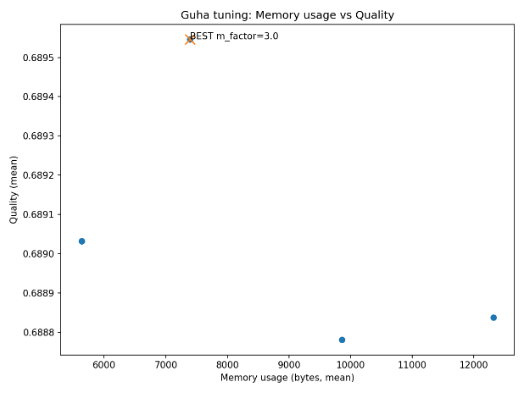 | 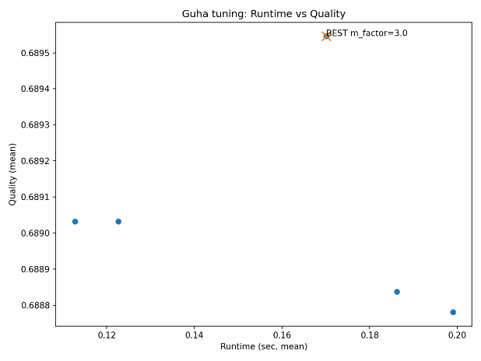
memory_vs_quality | runtime_vs_quality

6.1.2 Ailon Streaming k-means#
The Ailon algorithm exposes parameters controlling the coreset size and the number of repetitions.
The following figures illustrate the effect of these parameters on clustering performance.
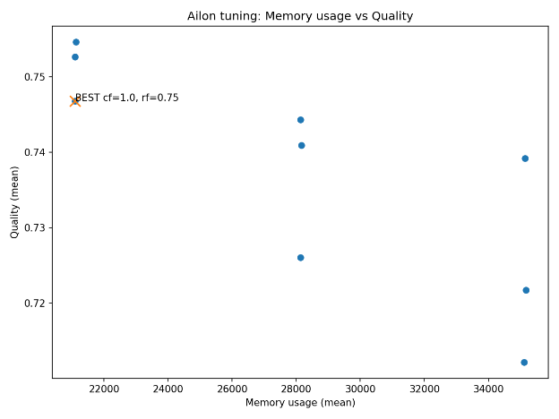 | 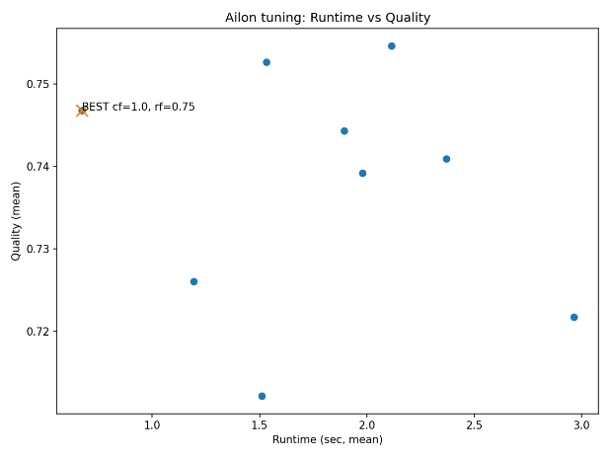
memory_vs_quality | runtime_vs_quality

6.1.3 Boutsidis Random Projection
The Boutsidis algorithm depends primarily on the projection dimension controlled by the approximation parameter ε.
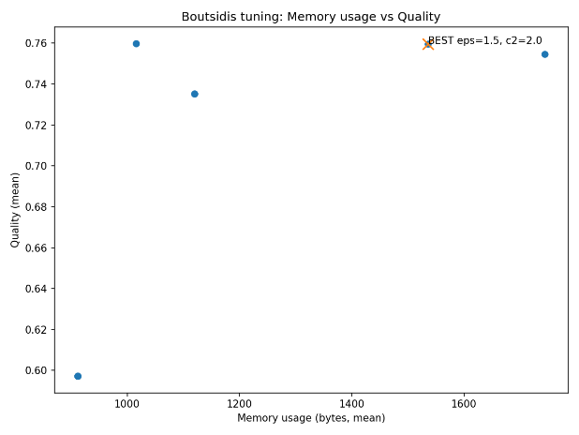 | 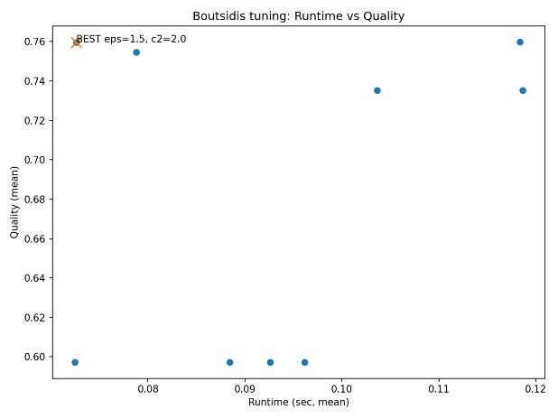
memory_vs_quality | runtime_vs_quality

6.1.4 Charikar Facility Location
The Charikar algorithm uses parameters controlling the probability of opening new cluster centers.
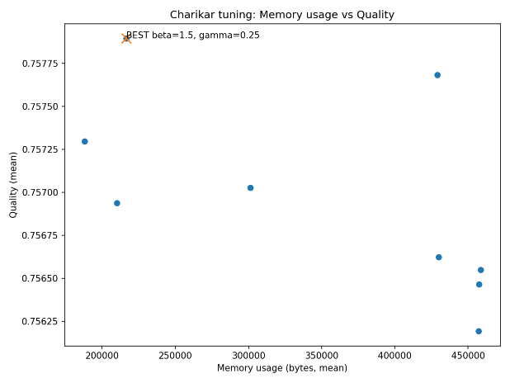 | 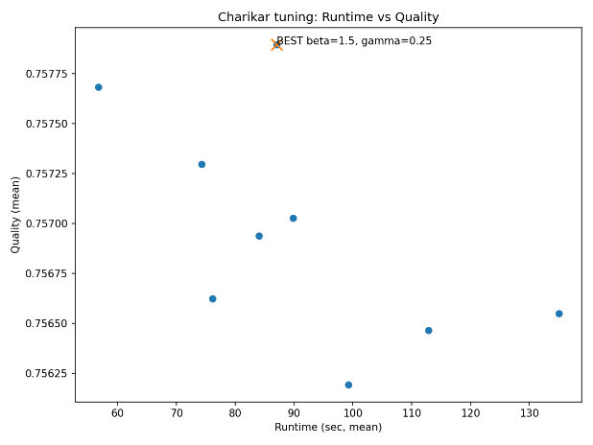
memory_vs_quality | runtime_vs_quality

6.2 Overall Algorithm Comparison
After selecting the best parameter configuration for each algorithm, the algorithms were evaluated on the full set of datasets.
The experiments included both synthetic datasets with varying configurations and real-world datasets.
The following metrics were recorded:
- Runtime
- memory usage
- SSE
- ARI
- NMI
All experimental results were aggregated into a single results table.
Table: Aggregated results across all datasets
#### [Insert aggregated CSV table or summary]
The full results are stored in the file:
results/Kmeans_sweep_raw.csv
This file contains the detailed measurements for all datasets, algorithms, and random seeds.

6.3 Global Trade-off Analysis
To compare the algorithms globally, we analyze the trade-off between memory usage, runtime, and clustering quality across all datasets.
#### Figure 1 — Quality vs Memory
[Insert global memory vs quality plot]
#### Figure 2 — Quality vs Runtime
[Insert global runtime vs quality plot]
#### Figure 3 — Runtime vs Memory
[Insert runtime vs memory plot]
These plots summarize the overall performance differences between the algorithms.

7. Empirical Validation of Theoretical Assumptions
Several theoretical predictions from the literature were evaluated empirically in our experiments.

7.1 STREAM Algorithm
The STREAM algorithm maintains a hierarchy of summaries representing the data stream.
Theoretical analysis suggests that increasing the summary size improves the approximation quality of the clustering solution.
Our experiments confirm this behavior.
Larger summary sizes lead to improved clustering quality but also increase memory consumption.
This result is consistent with the theoretical analysis of the merge-and-reduce framework.

7.2 Ailon Streaming k-means#
The Ailon algorithm relies on randomized sampling to construct a coreset of the data stream.
Theory suggests that increasing the number of sampled representatives and the number of repetitions improves clustering stability.
Our experiments confirm this trend.
Increasing the coreset size leads to improved clustering quality but increases runtime due to the additional sampling and clustering steps.

7.3 Boutsidis Random Projection
The Boutsidis algorithm uses random projections to reduce the dimensionality of the data.
Theory predicts that increasing the projection dimension improves the accuracy of distance preservation.
Our experiments confirm the predicted trade-off.
Smaller values of ε lead to larger projection dimensions, which improves clustering quality but increases runtime and memory usage.
However, since our datasets have relatively small dimensionality (10–25 dimensions), the advantages of dimensionality reduction are less pronounced than in very high-dimensional datasets.

7.4 Charikar Facility Location Algorithm
The Charikar algorithm dynamically opens cluster centers based on the distance between incoming points and existing centers.
Theory predicts that allowing more centers improves clustering accuracy.
Our experiments confirm that configurations allowing more cluster openings generally produce lower clustering error, at the cost of increased memory usage.

8. Discussion
The experiments highlight several important insights.
Streaming algorithms can significantly reduce memory usage compared to offline methods while maintaining reasonable clustering quality.
Different algorithms exhibit different trade-offs between runtime, memory usage, and clustering accuracy.
Random projection techniques provide theoretical advantages that become more visible in higher dimensional datasets.
Parameter tuning plays a crucial role in balancing computational efficiency and clustering performance.
Overall, the experiments demonstrate that streaming clustering algorithms provide practical solutions for large-scale data streams where traditional offline algorithms become computationally expensive or memory intensive.

9. Conclusion and Future Work
In this project we implemented and evaluated several streaming algorithms for k-means clustering.
The experiments demonstrate that streaming algorithms can achieve competitive clustering performance while using significantly less memory.
Future work may include:
- evaluation on larger real-world datasets
- experiments in higher dimensional settings
- exploring sliding-window streaming models
- investigating additional streaming clustering algorithms

10. References
- Guha, S., Mishra, N., Motwani, R., & O'Callaghan, L. (2002). Streaming-data algorithms for high-quality clustering.
- Ailon, N., Jaiswal, R., & Monteleoni, C. (2009). Streaming k-means approximation.
- Boutsidis, C., Zouzias, A., & Mahoney, M. (2014). Randomized dimensionality reduction for k-means clustering.
- Charikar, M., O'Callaghan, L., & Panigrahy, R. (2003). Better streaming algorithms for clustering problems.

